**Challenge 07 - Bootstrap**

For this week’s challenge, you’ll need to create a fully responsive page using **bootstrap**. Refer to the *screenshots & video* folders to see the exact look of the page.

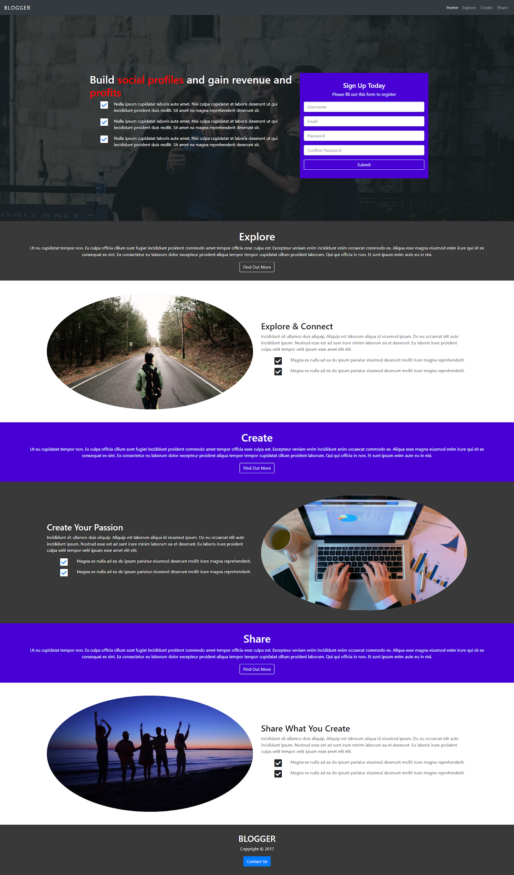

The navbar is fixed to the top and must open the navbar links when clicked on the hamburger menu, on mobile.

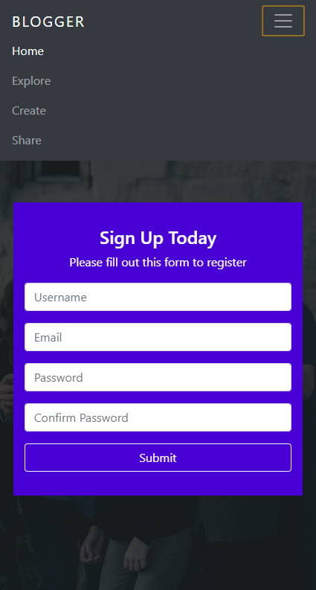

There is a plus functionality that you will have as a challenge to make, and that is the **scrollspy**. What this does is: when you scroll the page, the links in the navbar get highlighted.

#### 

#### Evaluation system:

**1 point** - Whole page completed in HTML & CSS.

**3 points** - All of the above + responsive for tablet & mobile.

**5 points** - All of the above + make the **hamburger work** + make the **scrollspy work**.

#### Deadline:

**1 week after its presentation, 23:59h end of the day.**

#### Hints:

* Read about scrollspy and how it works.

#### Note:

* Bootstrap is a **must** for this challenge.